Name QASIM HASSAN SMIT04588

Measures of Central Tendency and Dispersion

**Statistics** are numerical values used to summarize and compare sets of of data. Two important types of statistics are *measures of central tendency* and *measures of dispersion.*

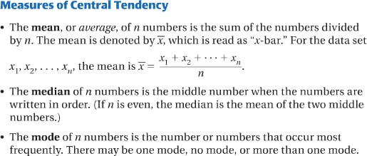A **measure of central tendency** is a number used to represent the center or middle of a set of data values. The *mean, median,* and *mode* are three commonly used measures of central tendency.

# QUESTION NO :1

# Find the mean, median, and mode of the data set.

1 . 1 , 6 , 3 , 9 , 6 , 8 , 4 , 4 , 4

**SOLUTION:**

Mean = (1+6+3+9+8+4+4+4)/9 = 5

Median = (1+3+4+4+4+6+6+8+9) = 4

Mode = 4

**RESULTS:**

Mean = 5 Median = 4 Mode = 4

2 . 1 , 5 , 6 , 2 , 6 , 1 , 7 , 6 , 2

**SOLUTION:**

Mean = (1+5+6+2+6+1+7+6+2)/9 = 4

Median = (1+1+2+2+5+6+6+6+7) = 5

Mode = 6

**RESULTS:**

Mean = 4 Median = 5 Mode = 6

1. **Quiz Scores** The data set below gives the quiz scores for a student on quizzes consisting of 10 questions each.

7, 9, 7, 10, 8, 7, 9

**SOLUTION:**

Mean = (7+9+7+10+8+7+9)/7 = 8.12

Median = (7+7+7+8+9+9+10) = 8

Mode = 7

**RESULTS:**

Mean = 8.12 Median = 8 Mode = 7

1. **Travel Distance** The data set below gives the distance (in miles) that several people travel to and from work each day.

12, 15, 11,8, 11, 13, 10, 16

**SOLUTION:**

Mean = (12+15+11+8+11+13+10+16)/8 = 96/8 = 12

Median = (8+10+11+11+12+13+15+16) = 11.5

Mode = 11

**RESULTS:**

Mean = 12 Median = 11.5 Mode = 11

1. **Oil Change** The data set below gives the waiting time (in minutes) of several people having the oil changed in their car at an auto mechanics shop.

22, 18,25,21,28,26,20,28,20

**SOLUTION:**

Mean = (12+15+11+8+11+13+10+16)/8 = 96/8 = 12

Median = (8+10+11+11+12+13+15+16) = 11.5

Mode = 11

**RESULTS:**

Mean = _____ Median = _____ Mode = _____

1. **Hockey** The data set below gives the number of goals for the 10 players who scored the most goals during the 2003 -2004 National Hockey League regular season.

41, 41, 41, 38, 38, 36, 35, 35, 34, 33

**SOLUTION:**

Mean = (12+15+11+8+11+13+10+16)/8 = 96/8 = 12

Median = (8+10+11+11+12+13+15+16) = 11.5

Mode = 11

**RESULTS:**

Mean = _____ Median = _____ Mode = _____

**Measures of Dispersion** A *measure of dispersion* is a statistic that tells you how dispersed, or spread out, data values are. One simple measure of dispersion is the **range,** which is the difference between the greatest and least data values.

**Standard Deviation** Another measure of dispersion is *standard deviation*, which describes the typical difference (or *deviation)* between a data value and the mean.

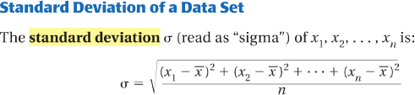

# Find the range and standard deviation of the data set.

7. 12,8,17,15,12,14

Range = _______ σ = ________

8. 17,14,24,21,30,20

Range = _______ σ = ________

9. 22,24,31,34,23,27,21

Range = _______ σ = ________

10. 31,46,39,43,32,35,40

Range = _______ σ = ________

**Outliers** Measures of central tendency and dispersion can give misleading impressions of a data set if the set contains one or more *outliers.* An **outlier** is a value that is much greater than or much less than most of the other values in a data set.

11. Consider the data set: 11, 15, 10,37, 17, 14,9, 15

1. Identify the outlier in the data set.
2. Find the range and standard deviation of the data set when the outlier is included and when it is not.

Outlier included: Range=

σ = ________

Outlier not included: Range=

σ = ________

# Identify the outlier in the data set. Then find the mean, median, mode, range, and standard deviation of the data set when the outlier is included and when it is not.

12. 4, 6,10, 2,90, 3,10, 5, 1

Outlier:

Outlier included: Mean =

Median =

Mode

Range=

σ = ________

Outlier not included: Mean =

Median =

Mode

Range=

σ = ________

13. 52,61,55,1,59,68,69,55

Outlier:

Outlier included: Mean =

Median =

Mode

Range=

σ = ________

Outlier not included: Mean =

Median =

Mode

Range=

σ = ________



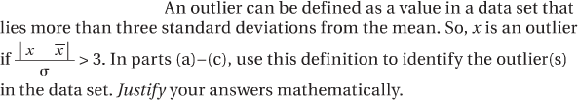

**Outlier Definition:**

14. a. 70, 55, 54, 74, 60, 58, 55, 56, 6, 62, 68, 94, 55, 82, 69, 74

b. 18, 20, 22, 25, 16, 40, 24, 19, 38, 3, 21, 27, 88, 24, 23, 26

c. 50, 93, 81, 84, 88, 85, 90, 99, 92, 199, 96, 89, 87, 94, 37